You are coming for a glamping holiday
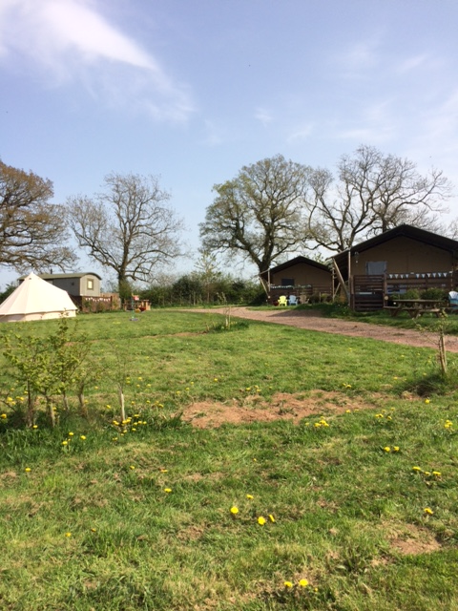
at
Leafy Fields in Devon.

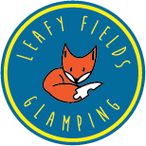

We are the Sheard family, we own the campsite.

We are Dannie and Andrew.
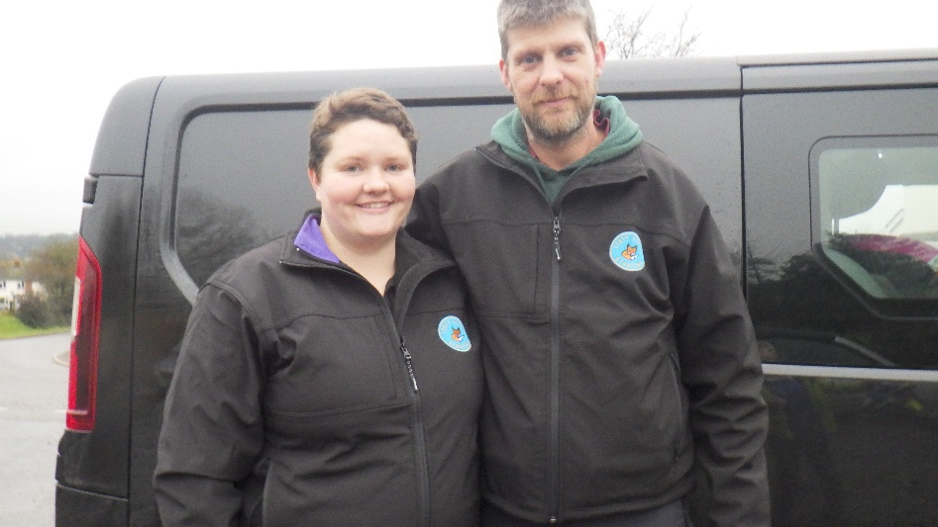
We have 3 children. Clive is 11, Blake is 8 and Alex-Mai is 5
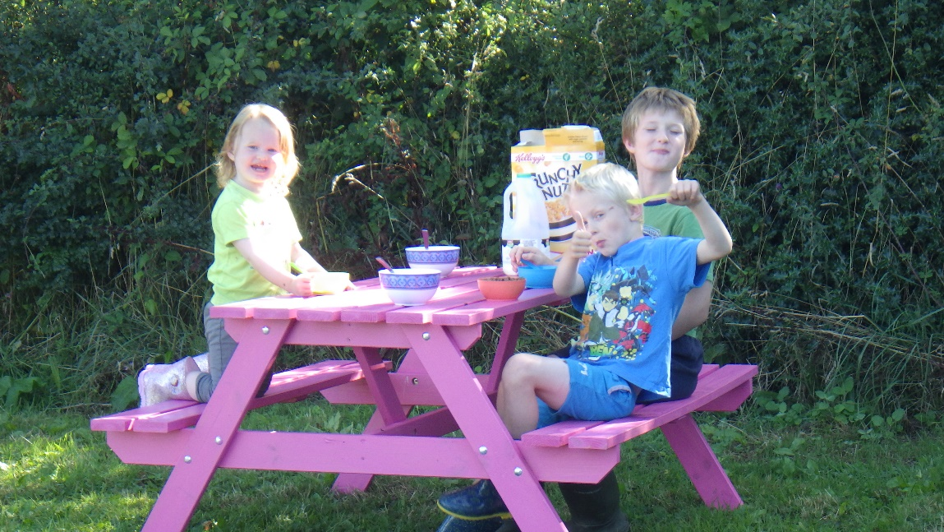

We have 4 little horses on our field for you to meet.
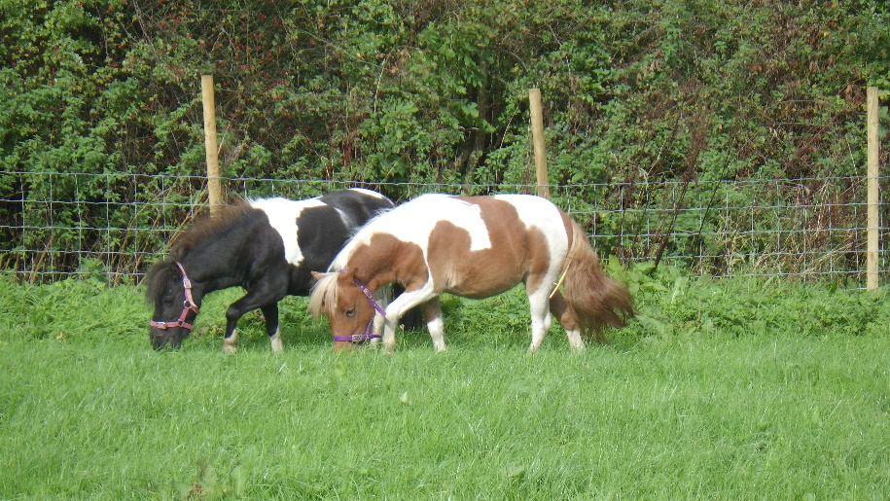
They are called Bella, Lilly, April and Minty.
There are also two cats Bobbie and Brian
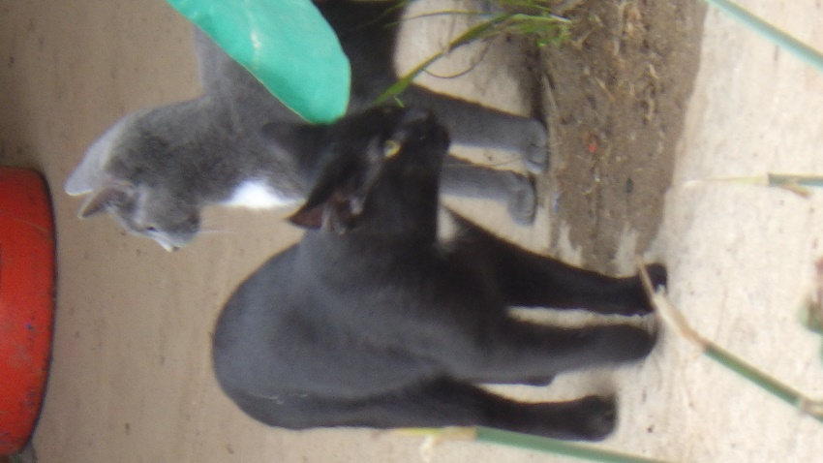

You will be sleeping in a shepherd hut, called Crivens.
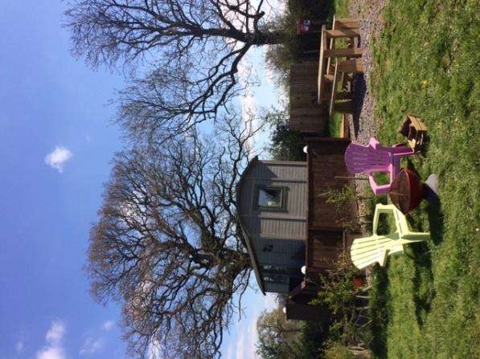

There is a toilet and shower in the safari lodge.
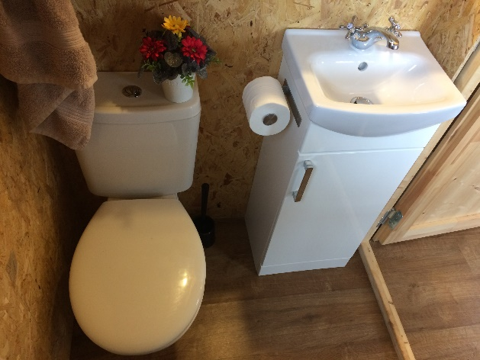
There is a small kitchen and a table to eat at like this one
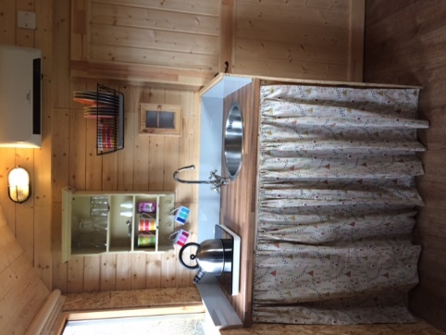
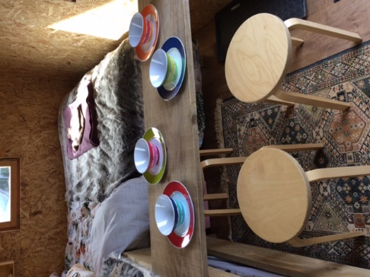

If it is a warm and dry night you might have a camp fire before bed time.

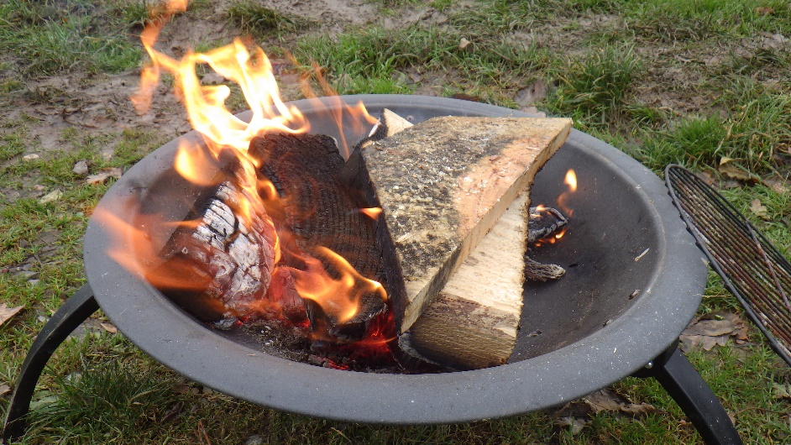

Your shepherd hut has beds, heating and electric lights in it.

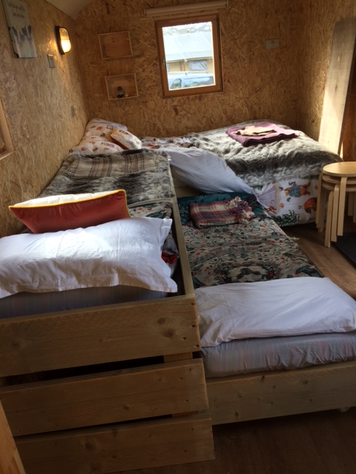

We have a sensory play room that you might like to explore.
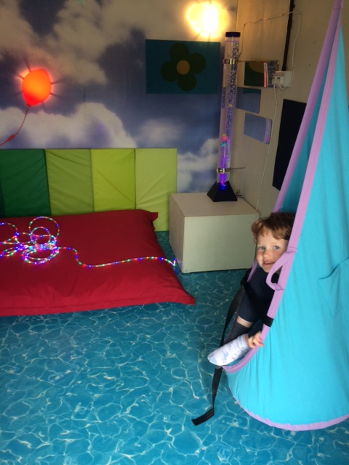
There is a climbing frame you might like to play on
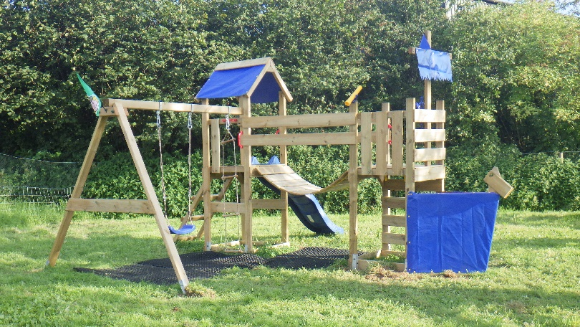

Our field is next to a Dairy farm which has lots of Cows and tractor that you might be able to hear. The cows Moo and the tractors have noisy engines. You might smell the cows sometimes too.
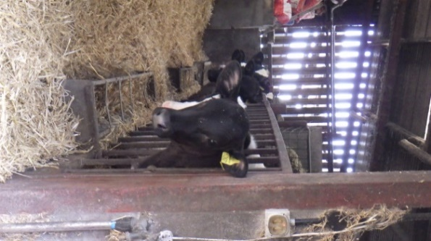
We are really looking forward to meeting you.

